Geomechanics Exercises

File “Geomech_Exercise_1.xlsx” contains well logs and a velocity survey.

**1. Overburden and Stress**

A. Compute overburden using the velocity survey and the empirical relation between slowness and density. Water depth is 6625 ft.

Compute sonic slowness in microseconds/foot in each depth interval below water bottom

Use the empirical correlation in the figure to compute density in each interval.

Assume that seawater density is 1.03 g/cm3.

Assume that acceleration of gravity is 0.433 psi/ft.

Compute overburden by summing gravity*density*thickness.

Assume overburden is zero at surface.

B. The well logs start at MD=16720 ft. Assume the well is vertical.

Add a column with vertical depths relative to the surface. The K.B. elevation is 46 ft.

Use the overburden from the velocity survey at TVDSS = 16832 ft as the starting point, and integrate the well log density from 16832 ft on down.

C. There is a sandstone starting at 17515 ft. MD. Assume that a formation test at 17,545 ft. MD measured a pore pressure of 11000 psi. What is the vertical effective stress at that point?

D. Assume the shale and sand pressures are in equilibrium and that the pore pressure varies at a gradient of 0.45 psi/ft in the sand. Ignore buoyancy effects due to presence of hydrocarbons.

What are the pore pressure, overburden and vertical effective stress at the top of the sand at 17,515 ft MD?

What are the horizontal stresses in the sand and the shale at 17,515 MD, and what is the horizontal stress contrast? Note that this stress contrast is about what is needed to contain a fracture within the sand. High porosity poorly-consolidated sands like this often use “frac-pack” completions.

**2. Borehole Breakouts**

File: “Geomech_Exercise_2.xlsx”

Use the stresses from exercise 1 at 17545 MD. Assume that SHmax is halfway in between Shmin and Sv. Assume that the sand fails in shear according to a linear Mohr-Coulomb criterion with Cohesion = 300 psi and friction angle = 40 degrees. At what mud pressure will borehole breakouts initiate. Assume the mud forms a perfect mudcake and that there are no differences in temperature or chemical activity between the mud and the formation.

Start with file “Geomech_Exercise_2.xlsx”, which has dummy values for max and min effective stress and uses them to plot a Mohr circle.

For an assumed starting value for mud pressure, Pmud, compute the radial effective stress and tangential effective stress at the borehole wall along the minimum stress direction, as shown in this figure. Set the Mohr circle max and min stresses to these radial and tangential values.

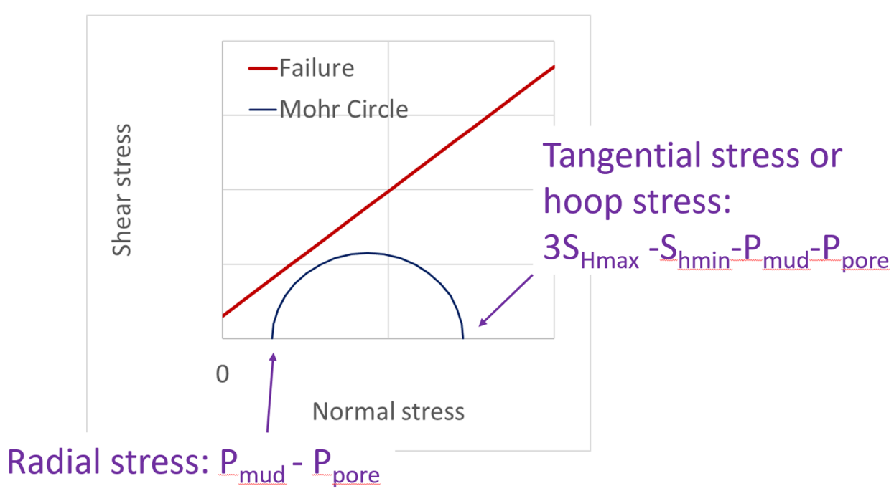

Plot the linear Mohr-Coulomb failure line on the Mohr-circle plot.

$shear stress=cohesion+\left(normal stress\right)*tan⁡(frictiion angle)$

Then play with the value of Pmud to make the Mohr circle just graze the failure line.

This is the minimum mud pressure to keep the borehole stable (given the assumptions). Is it higher or lower than the pore pressure? Depending on the stresses and on the rock strength, the miminum mud pressure for borehole stability could be higher or lower than the pore pressure. Drillers must keep the mud pressure higher than the pore pressure to prevent kicks, and also high enough to

**3. Reservoir poroelastic properties**

A. Drained frame properties. In geomechanics we are usually interested in “drained” frame elastic properties, which are properties measured with constant pore pressure. Sonic logs measure the stiffness of rock with pore pressure varying as a stress wave passes. So if we start out with dynamic well-log properties we need a way to estimate the drained rock properties. Gassmann’s equations relate the drained frame properties to saturated rock properties:

$$\frac{K_{SAT}}{K_{GR}-K_{SAT}}=\frac{K_{DR}}{K_{GR}-K_{DR}}+\frac{K_{FL}}{K_{GR}-K_{FL}}\frac{1}{φ}$$

$G_{DR}=G_{SAT}$

Where K is the bulk modulus, G is the shear modulus, $φ$ is porosity, and subscript DR is for the drained frame, subscript SAT is for the saturated rock, and subscript FL is for the pore fluid.

Given density, ρ, compressional and shear velocity, $V_{p}$ and $V_{s}$, the bulk and shear moduli are

$K= {ρ{V_{p}}^{2}-\frac{4}{3}ρ{V_{s}}^{2}}_{}$

$G= {ρ{V_{s}}^{2}}_{}$

With velocities in km/s and density in g/cm3, the moduli are in GPa.

Use the provided excel file “Geomech_Exercise_3.xlsx” to compute the drained frame properties at MD =17545 ft in the example well. Use the following rock and fluid properties.

|  |  |  |  |
| --- | --- | --- | --- |
| Mineral and fluid properties | | |  |
| Kgrain | 40 | GPa | Bulk Modulus solid grains |
| Kwater | 3.2 | GPa | Bulk Modulus of pore water |
| Khc | 1 | GPa | Bulk Modulus of hydrocarbon |
| RHOgrain | 2.65 | g/cm3 | Density of solid grains |
| RHOwater | 1.05 | g/cm3 | Density of pore water |
| RHOhc | 0.66 | g/cm3 | Density of hydrocarbons |

Use the well-log porosity, density, saturation, and sonic slownesses.

Compute the drained frame Young’s Modulus, E, and Poisson’s Ratio, 𝜈:

$$E= \frac{9 K G}{3K+G} ν= \frac{3 K-2 G}{2(3K+G)}$$

Compute the poroelastic effective stress coefficient

$$α=1-\frac{K_{DR}}{K_{GR}}$$

**4. Reservoir Sand Failure**

Use sand properties from MD 17545 in exercise 1 and 3, and “Reservoir Failure.xlsx”

A. Reservoir compaction due to production drawdown.

Start with the in-situ stress state and rock properties for the reservoir from exercises 1 and 3 at measured depth 17545 ft.

Assume that SHmax is halfway in between Sv and Shmin.

Compute the in-situ mean effective stress and shear stress (p and q) assuming that the effective stress coefficient α=1 for both failure and elastic deformation.

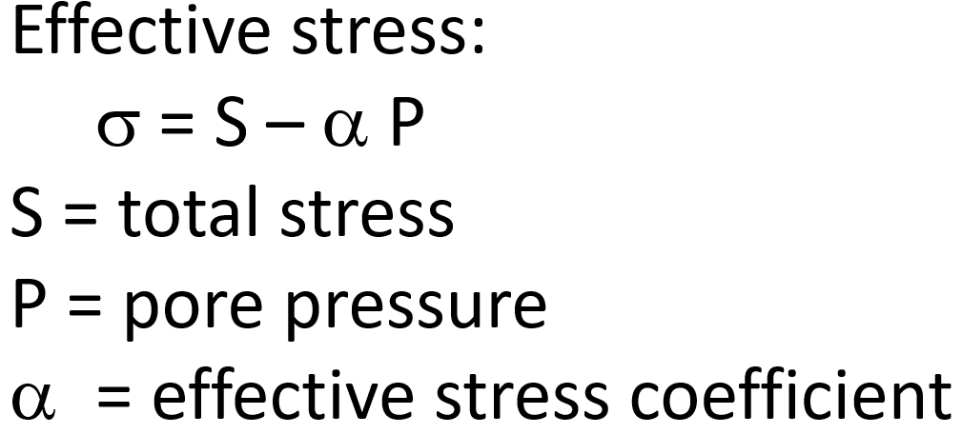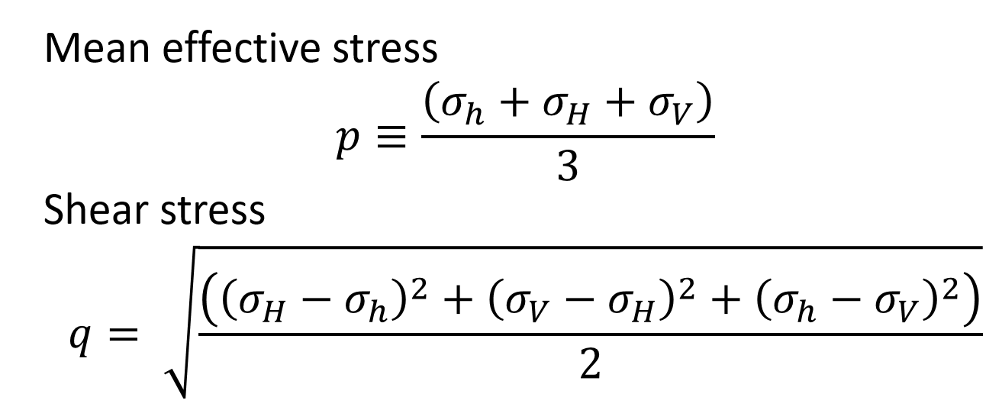

Plot the in-situ effective stress (p,q) on the failure diagram in the supplied excel file.

Compute the trajectory on the p-q diagram as the pore pressure increases due to injection. Assume that the reservoir is thin, flat, and with high enough permeability that strain is essentially only vertical. For uniaxial vertical strain, the changes in effective stress are

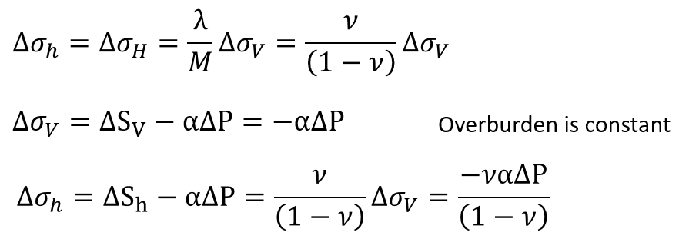

Assume α=1 for both elastic deformation up to failure and for failure. On the p-q plot, follow the linear trend starting from the in-situ point until it intersects the failure envelope. At what reservoir pressure will the reservoir fail in compaction?

B. From exercise 2, you know that the effective stress coefficient for elastic deformation is not 1 but is smaller. Starting from the in-situ stress state, as pore pressure P decreases, compute how Sh, SH, and Sv change using the elastic equations above with α from exercise 3. Then compute how p and q for failure change with pore pressure and estimate the pressure at which failure occurs.

Note that a more realistic model would let the reservoir strain horizontally with a more localized pressure drawdown. That would decrease the change in shear stress relative to the change in mean stress. So the p-q trajectory would be flatter and failure would be more compactive. A higher Poisson’s ratio would also flatten the p-q trajectory.